User Guidelines ANPR System

This topic is based on both research and product.

Following are the key benefit points on how the project can be utilized:

* 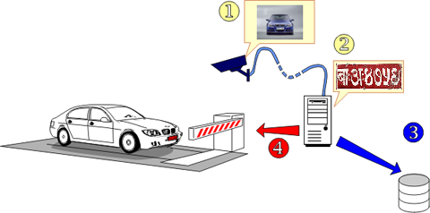24/7 monitoring and Surveillance
* Less Manned Surveillance
* Enforcement of traffic rules
* Still and Video Footage
* Toll Gate Vehicle Access
* Parking charge for vehicles
* Real time detection
* Easy and efficient
* Cost-effective
* Provides evidence
* Recovery of stolen cars
* National security and counter terrorism
* Local crime
* 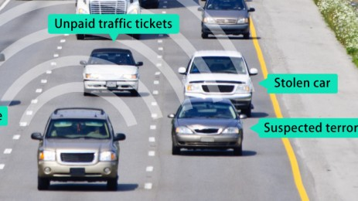Community confidence and reassurance
* Crime prevention and reduction

Where this product will be implemented:

* Law enforcers
* Department of Transportation Management
* 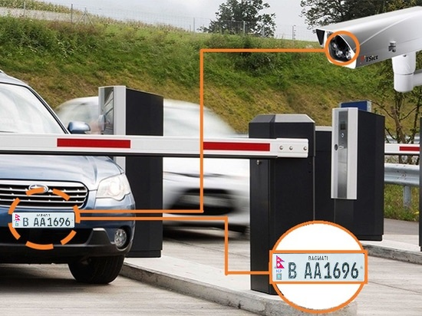Malls / Shopping complex
* Parking safety
* Airports
* State borders
* Highways
* Country borders
* Traffic light junctions
* Offices
* Houses
* High security areas
* Schools

# Further elaboration on how this research product will be used in real time scenario:

### Security:

Firstly, if people know there is a system that there might be a camera that tracks and record their vehicle movements, they would definitely think twice before breaking any laws which will result in decrease in criminal activities. Police officials can use ANPR to track suspicious vehicles or vehicles that were involved in some crime.

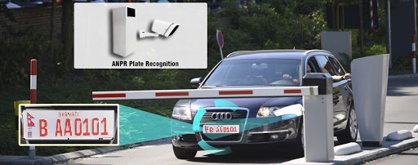The ANPR can also be used in places where only authorized vehicles have the pass to enter and will recognize and warn if any unauthorized or banned vehicles will enter the premises.

### Service:

ANPR can provide automated services as they can track through a camera on a live video and a system with enough machine learning can be even more dependable than any other source.

They can also be used for parking solutions where it can be used through help of cameras by recording the time of the vehicles arrival and calculating the time of their departure. This can also benefit the current situation and less interaction between people while paying the parking fee.

### Real time benefits:

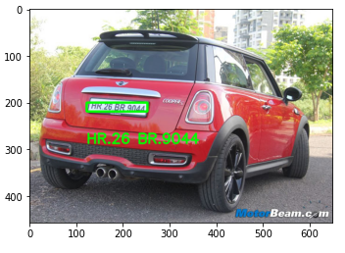The system of ANPR can be valuable to a lot of companies and different sectors of corporation cause of the real time benefits it offers. In many lawsuits it takes a lot of time to pass the sentence and for the culprit to face penalty. Through ANPR, the plates can be stored into a database and can be searched for any suspicious activities.

As the video stream can work in real time, the traffic CCTVs can also capture which vehicle is making the traffic jam, and is there might be any discomfort to any vehicle and can send help if needed to that sector.